Pickleball Safety First
Pickleball is not only fun but is great exercise too.
Like any other sport, care must be taken to avoid overexertion and injury.
Below are some of the things you should do to stay healthy and have more fun.
- Warm-up and Stretch
Following a full body warmup period (fast walk to the court?), begin a stretching program. Start with the ankle stretch (Achilles) and work other muscle groups on the way to the shoulder/neck area.
- Never back up on your heels
Learn to return lobs correctly. If the ball goes over your head; go sideways or turn around and go back to get to the ball.
- Wear court shoes
Comfortable court shoes are a must. Unlike running shoes or sneakers however, court (or tennis) shoes offer lateral support for swift movement in all four directions. Court shoes are specially designed to prevent ankle injuries. They do cost a bit more. Broadly speaking, all tennis shoes are sneakers, but not all sneakers are tennis shoes.
- Wear eyewear
While hollow and lightweight, the ball used in pickleball is a hard polymer and can travel at a very high rate of speed. Sunglasses or even a lens-less frame will help.
- Keep hydrated
Be sure to drink water, replenish electrolytes and eat appropriate snacks.
- Wear sun protection
Nuf sd.

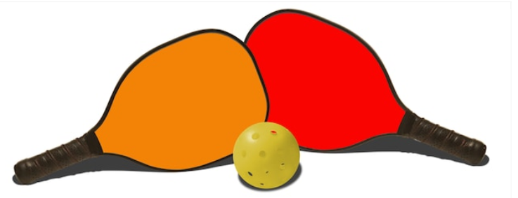
Source: https://www.usapa.org/health-safety/

